Revised September 2019
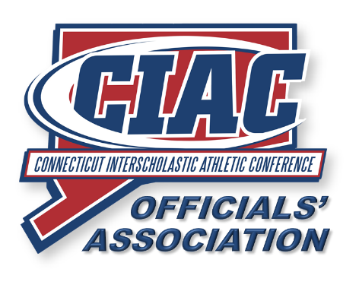

TO: Current High School Sports Officials and New Candidates

FR: Dan Scavone, CIAC Director of Officials

Thank you for your interest in officiating high schools sports in Connecticut. Officials serve an important role and contribute significantly to the integrity of high school competition. Please be advised that all new candidates must be cleared through a CIAC background check to be placed on the approved list, from which member schools must obtain officials. Additionally, current members can be subject to a follow-up background check at any time at the discretion of CIAC.

Thank you for your cooperation in reading and signing the CIAC background check consent form below and returning it to your local board.

CIAC BACKGROUND CHECK CONSENT FORM
By signing this consent form, I acknowledge that I will be subject to a criminal background check. I understand that if I choose not to sign this consent form, I will not be included in the approved list of officials authorized to officiate high school sports in Connecticut. I further understand that it may be necessary for CIAC to disclose information regarding my criminal history to the commissioner or designee of my local board.

Print Name __________________________________________________

Middle Name or Initials________________________________________

Maiden/Former Name _________________________________________

Date of Birth _______________________

Signature ____________________________________________________

Today’s Date _____________________

